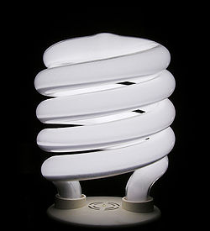

Energy Efficiency Assignment

Planning sheet

Item I choose……...........................................

Diagram of my item

What type of energy does it use?

ENERGY IN ENERGY OUT

Explain 4 ways in which your item is energy efficient.
 | 4 Ways this | Item is | Energy | Efficient
 | 1 | 2 | 3 | 4
List
Explain
Science ideas

Explain one way in which your item could be MADE MORE energy efficient.

List

Explain

Science understanding

What diagrams will I use?

Captions for diagrams

Labels

Bibliography

2 sources of information

Internet

Book

